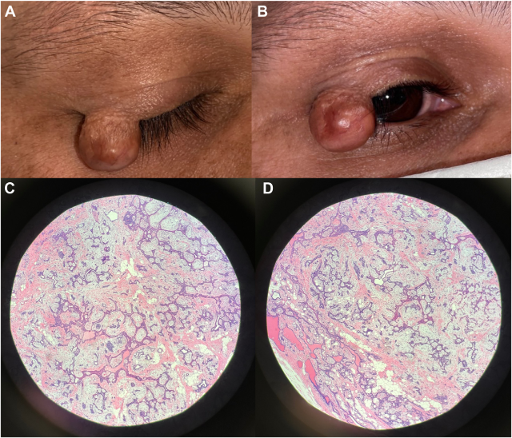

A 34-year-old man presented with a lesion that progressively enlarged for 5 years. Examination revealed a reddish right upper eyelidmargin mass that was tender to palpation (A, B). Visual acuity was 20/25 in both eyes, and the temporal visual field was limited on the right.Excisional biopsy was performed, and histopathology revealed ribbons of epithelial cells and adipose tissue amidst a background (C, D). Based on the provided images and clinical description please make an ophthalmic diagnosis for this patient. And output the diagnostic conclusions only.

**The ophthalmic diagnosis for this patient is a sebaceous gland carcinoma.**